Scheduling a meeting using the Microsoft Teams app
Requirements
- Microsoft Teams app for Windows
- Teams Dial-in Number assigned to the scheduler for telephone call-in

Procedure
- Click on Calendar on the left-hand side of the Teams app.
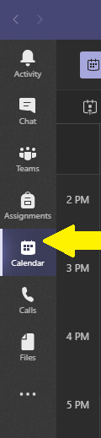

- In the calendar on the right-hand side click on the block for the time you want to meet. The new meeting window will appear. In this example, I’ll be creating a meeting for Monday at 9 AM.
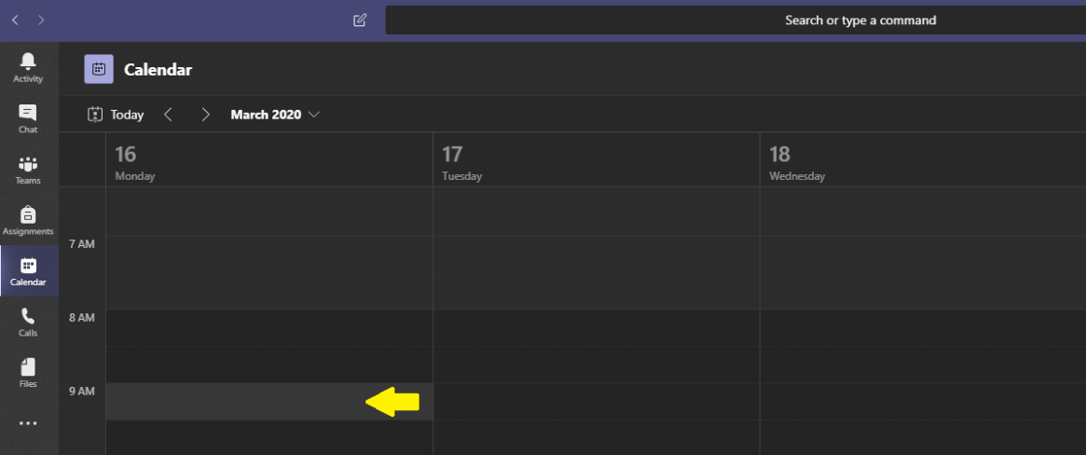

- Add a title, attendees (both required and/or optional), and select the start and end time of the meeting. NOTE - You can add attendees who are not a member of the Team involved in the meeting.

- If you want to schedule a recurring meeting use the drop-down menu to select the correct recurrence.

- If the meeting is associated with an existing MS Team (as opposed to a personal meeting), click on the Add channel field and select the correct channel from your list of Teams. You’ll need to click on the Team to view the channels. If you are unsure of the channel, it is most likely the General channel.

- Fill out the meeting details in the Details box. If you have been assigned a Microsoft Teams dial-in number, it will appear in the meeting details after the meeting is finished being created and is saved.

- Click Save in the upper right-hand corner to save your meeting. The selected attendees will be sent an email invite.

The locations for steps 3 through 7 are noted in the image below.
